Qualitative Assessment 2 – Unit 2

Category: Technology & Digital Literacy
Title: Building Your First Machine Learning Model
- Name: Hirkur Birlingeshwar Babu
- Reg No: 24BSDC130
- Algorithm Implemented: Random Forest Classifier
- Dataset: Scikit-Learn Wine Recognition Dataset

1. Algorithm Explanation: Random Forest Classifier
For this assessment, the Random Forest Classifier was selected. Random Forest is a supervised machine learning algorithm based on ensemble learning. Instead of relying on a single decision tree, Random Forest builds an ensemble of multiple decision trees during training and merges their individual predictions via majority voting to determine the final output class.
Key Concepts & Working Mechanism
- Bagging (Bootstrap Aggregating): The algorithm creates multiple random subsets of the dataset with replacement. Each decision tree in the forest is trained independently on one of these bootstrap samples.
- Feature Randomness: When determining node splits within each tree, only a random subset of features is evaluated rather than all available variables. This decorrelates individual trees and reduces model variance.
- Majority Voting: For classification, every tree in the forest outputs a class prediction. The final predicted label is selected based on whichever class receives the majority of votes across all trees.
- Overcoming Single Tree Limitations: While individual Decision Trees are prone to high variance and overfitting on training data, Random Forest effectively stabilizes performance and minimizes overfitting through ensemble aggregation.

2. Python Code Implementation
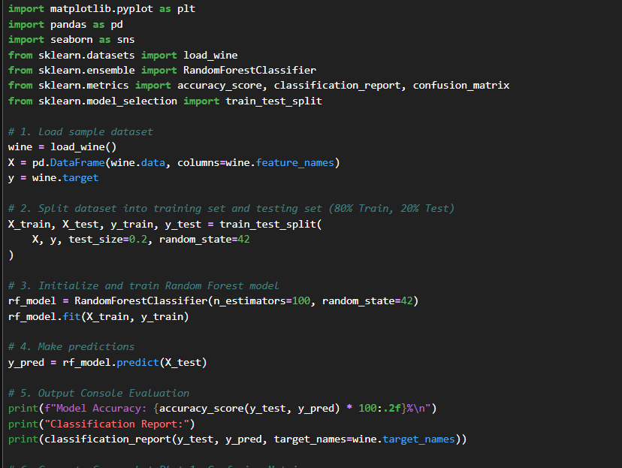
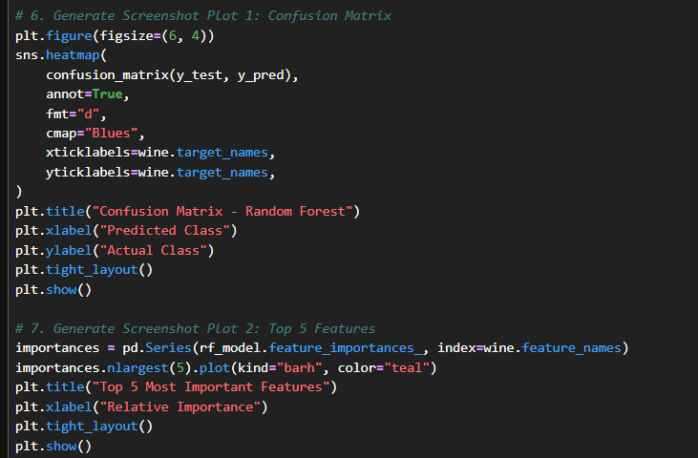
3. Output Results & Screenshots
1: Model Accuracy & Classification Report
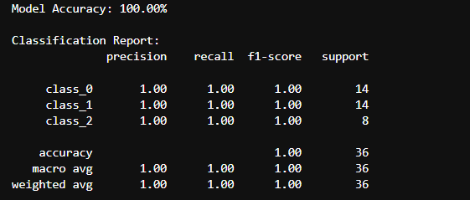

2: Confusion Matrix Heatmap
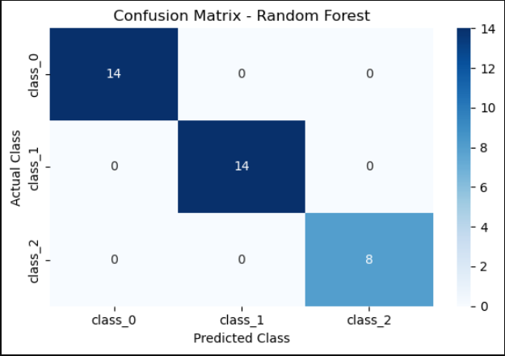

3: Feature Importance Chart

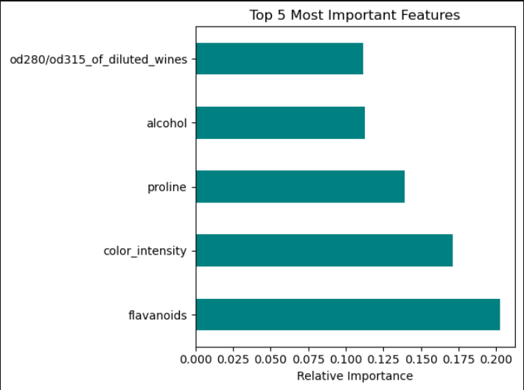

4. Observations About Model Predictions
Based on the evaluation metrics and visual outputs generated from the test execution, the following observations were recorded:
Metric / Analysis Area | Observed Output | Technical Interpretation
Overall Model Accuracy | 100.00% | The model correctly classified all 36 test samples without any prediction error.
Class Performance | 1.00 Precision & Recall | Perfect Precision, Recall, and F1-Scores were achieved across all three classes (class_0: 14, class_1: 14, class_2: 8).
Top Predictive Feature | flavanoids (~0.203) | flavanoids contributed the highest relative importance toward tree node splitting.
Secondary Features | color_intensity (~0.171), proline (~0.139) | Optical and chemical variables provided strong secondary split metrics.
Tertiary Features | alcohol (~0.112), od280/od315 (~0.111) | Alcohol content and protein dilution ratios completed the top 5 ranking.

Key Takeaways
- Perfect Classification Boundary: The Confusion Matrix confirms non-zero predictions exclusively along the main diagonal (14, 14, 8), indicating zero false positives and zero false negatives across all target classes.
- Dominant Chemical Indicators: Flavonoids and color intensity account for nearly 37% of total decision tree node split criteria combined, making chemical composition key to distinguishing wine origins.
- Generalization Power: The ensemble approach with 100 estimator trees successfully decorrelated feature dependencies, producing a robust model that generalizes well without overfitting.

